Day1：

Understand ISMART Capacity LTS project requirements.

Day2：

Learn ASP.NET WEB API

How to web update pages asynchronously using AJAX

Web api 网站：<http://wiki.jikexueyuan.com/project/web-api-book/1-Getting-Started/1-GettingStartedwithASP-NETWebAPI2.html>

With AJAX：

<https://www.w3schools.com/xml/ajax_intro.asp>

AJAX allows web pages to be updated asynchronously by exchanging data with a web server behind the scenes.

* Update a web page without reloading the page
* Request data from a server - after the page has loaded
* Receive data from a server - after the page has loaded
* Send data to a server - in the background

How AJAX Works

* 1. An event occurs in a web page (the page is loaded, a button is clicked)
* 2. An XMLHttpRequest object is created by JavaScript
* 3. The XMLHttpRequest object sends a request to a web server
* 4. The server processes the request
* 5. The server sends a response back to the web page
* 6. The response is read by JavaScript
* 7. Proper action (like page update) is performed by JavaScript

Day3：

Complete WBS and scope of the project.

Understand difference between ETL and ELT.

Continue to understand the requirement, our project is to build a dashboard system to achieve data migration using ASP.NET and Oracle (Previous one is using Netezza and Data Stage).

Get to know workflow of the previous system.

<https://www.cnblogs.com/zlslch/p/6906809.html>

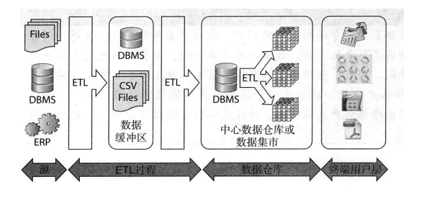

数据仓库典型架构图

　在上图中，有多个业务源系统，一个**数据中转区**，一个保存了所有历史数据的数据仓库和多个可以由终端用户访问的**数据集市**。

这些组成部分都是由数据整合过程来完成的，就是上图中显示的**ETL**。

在源系统和数据仓库之间，有一个数**据中转区，也可以叫做数据缓冲区**。它仅用来快速地从源数据系统中获取数据，并暂时保留这些数据。它不一定是一个数据仓库，在很多情况下，将数据保存在ASCII文件中比插入数据库表中还要快。

Day4:

Prepare the environment for software development.

Participate in the company's training, complete quiz.

Day5:

Reports are generated through raw data-block-statics-summary  
Learn what is data modeling.

Data modeling

Data

- Reference

- Master

- Transactional

Dimensional Modeling

- Fact (Measure)

- Dimension

- Star Schema

- Snowflake Schema

Determine which tables are included in the database (ISMRT_MV_PLS_TBL_LOGSHEET, ISMRT_TBL_LTSWPH_SETTINGS)